**Rapid Capture for Nitrate Negatives**

Prepared by Joseph Aaron Campbell November 2015

This guide describes the steps necessary to produce photography with a rapid capture station in regards to Nitrate negative digitization at the Chicago History Museum. It assumes the bare minimum of a camera, laptop, tether software, and light source are available. It utilizes a custom set of software to automate the post production of the finalized image file during the process of photography. Essentially creating the final ‘tiff’ image files in real time as the raw file is produced.

This is done through a windows batch file that continuously checks for new RAW images in a specific folder. If your camera sends a raw image to the ‘hot folder’ it will then check each image frame edge to see if it is black or not. Whichever image frame edge is black will become the bottom of the final image. Then the software will convert the raw image and output a ‘.tiff’. During this conversion the file is inverted, rotated, converted to grayscale, the black edge is removed, applies vignette/flatfield corrections, and supplies a unique serialized file name based off of user input.

This workflow was created in response to a massive digitization project of Nitrate Negatives and the lack of needed equipment and standard commercial software designed for rapid capture photography. It is designed to be open source and for Museums or Cultural Heritage institutions that do not have the resources to produce or purchase a state of the art digitization system.

**EQUIPMENT USED:**

1. Canon 5D MKIII with EF 50mm 1:2.5 Macro Lens
2. Manfrotto Mini Salon Camera Stand
3. Dell Alienware Laptop
4. Bretford #6000 Lightbox (4ft)
5. Generic Laptop Stand
6. Two 6in x 2in Black Matte Board Pieces ( size will vary based on size of object to be digitized)

**SOFTWARE USED**

1. Canon EOS Utility
2. Canon Digital Photo Professional 4
3. Custom Windows Software (Batch files)
   1. ‘Setup.bat’ : Creates all the needed folders and files to run the automated service.
   2. ‘Flatfield.bat’ : Creates the flat field tiff image from a source raw file needed to apply flatfield/vignette removal
   3. ‘Hotfolder.bat’ : monitors source folder for new RAW images. For each new unedited raw image convert and save ‘.tiff’ file. The hotfolder batch file completes the following list of actions:

**SETUP PHYSICAL WORKSPACE**

1. Work area should be clean of dirt, grime, or other unwanted elements
2. Basic setup will consist of object, object support, camera, camera stand, laptop with tether software, and a  light source such as a light box
3. Place the camera on the camera stand or tripod
4. Using a pitch finder or level, measure the angles parallel between the camera lens and object surface (do not measure on the actual object, measure the table to whatever is supporting the object). Make sure the camera lens matches the angle of the object support surface.
5. Place laptop nearby on stand or other support surface
6. Power on both the camera and the laptop
7. On the camera:
   1. turn off any special white balance
   2. turn off timers and ensure the camera is on ‘single shutter’ mode
   3. turn on AutoFocus for the lens if applicable, other wise use manual focus
8. Connect the camera to the usb cable
9. Connect the opposite end of the usb cable to the computer

**SETUP DIGITAL WORKSPACE**

1. Once the camera and computer are connected:
   1. Create a master working folder where new image files will be saved by the tether software.
   2. Copy the ‘Setup.bat’, ‘flatfield.bat’, and ‘hotfolder.bat’ files into the master working folder. These are windows batch files and look as the following:

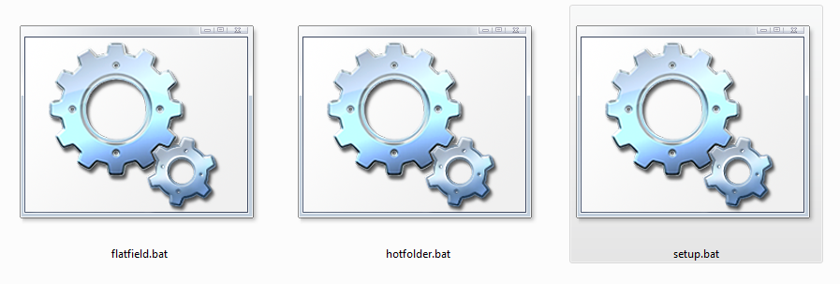

*Windows batch file icons*

* 1. Double click on ‘Setup.bat’. This will create all necessary subfolders and files needed to process the images produced during photography. This will include:
     1. Three empty folders : ‘Source’, ‘Raw’, and ‘Output’
     2. Empty Text files: ‘Source’ and ‘Output’
  2. Copy or place a ‘target.tif’ file into the ‘Source’ folder. This is used to create the target reference that’s added to the final ‘.tiff’ file if requested. Ours looks like this:

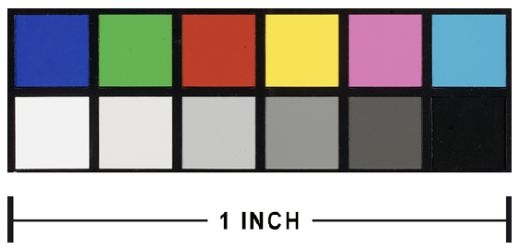

*CHM color reference/scale image*

* 1. Open tether software:
     1. Canon: ‘*Digital Photo Professional 4 (DPP)*’ and EOS Utility

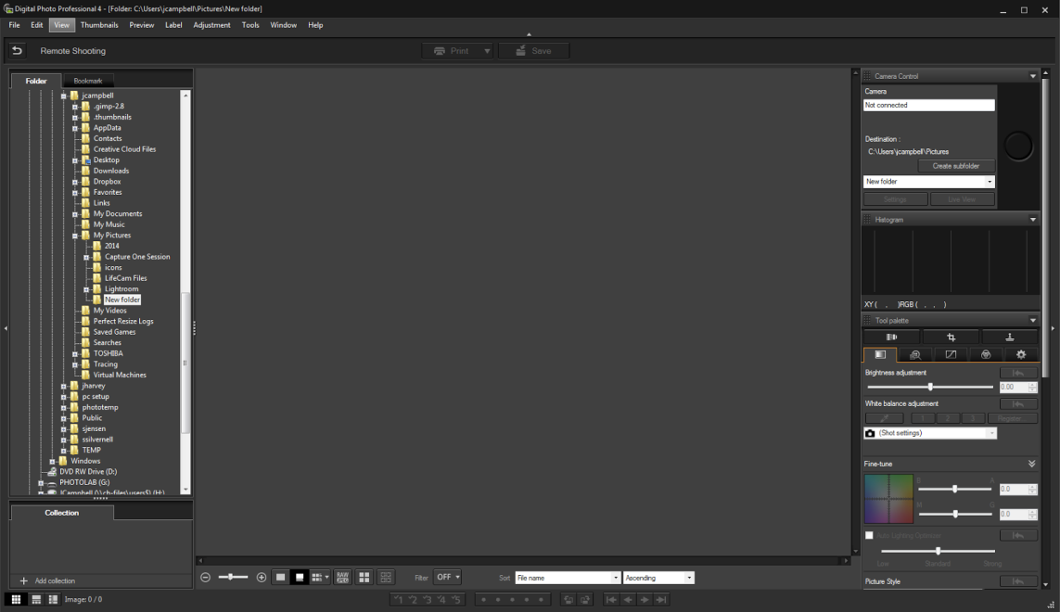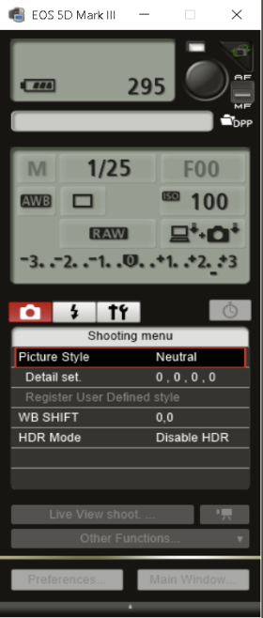

*Remote shooting view of Digital Photo Professional 4                            EOS Utility*

**START CAMERA CONNETION**

* + - 1. On the left side of the software window will be a file list
      2. Find and select the master folder containing the folders and batch files used for this project.
      3. At the top of the software window press the button “Remote Shooting”
      4. EOS Utility will start and a new window appears:
         1. Destination: Select ‘Current Folder’
         2. You do not need special file naming. Leave this as is.
         3. Press OK in the ‘Specify Remote Shooting Folder’ window

**SET UP IMAGE FRAME and AUTO ROTATE IMAGE EDGES**

* + - 1. Back in the Digital Photo Professional 4 window:
         1. In the top right under ‘Camera Control’

1. Press the ‘Live View’ button to bring up the live view
2. Place your object in the image frame and adjust the camera height until there is a sufficient border between the object and the image frame edge.
3. Focus the Lens on the focal plane of the object
4. Place the two 6in x 2in black matte board pieces into the Left and Bottom image frame edges
5. Be sure that only a small sliver of the black matte board pieces are visible in the image frame
6. Tape the black matte board pieces into place on one edge so as to allow them to be ‘flipped’ over one edge
7. See below:

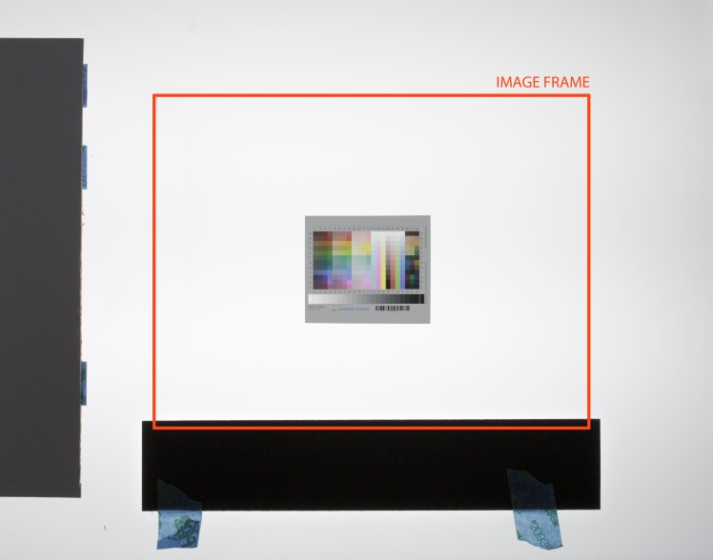 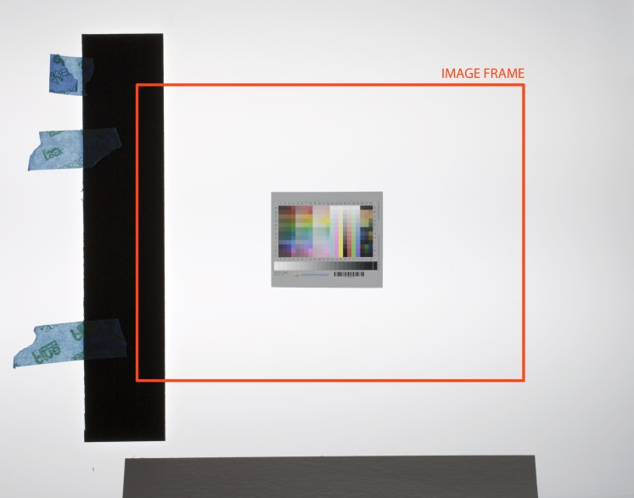

*Auto Rotate indicators: Left (Bottom edge ‘ON’; Left edge ‘OFF’) ; Right (Bottom Edge ‘OFF’, Left edge ‘ON’)*

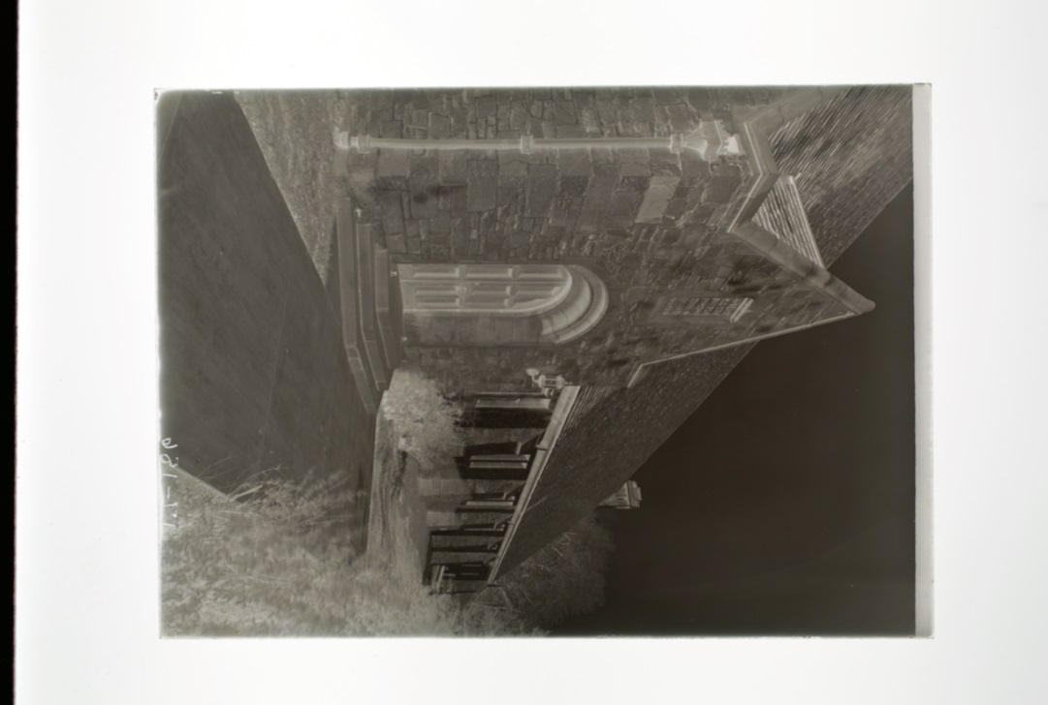 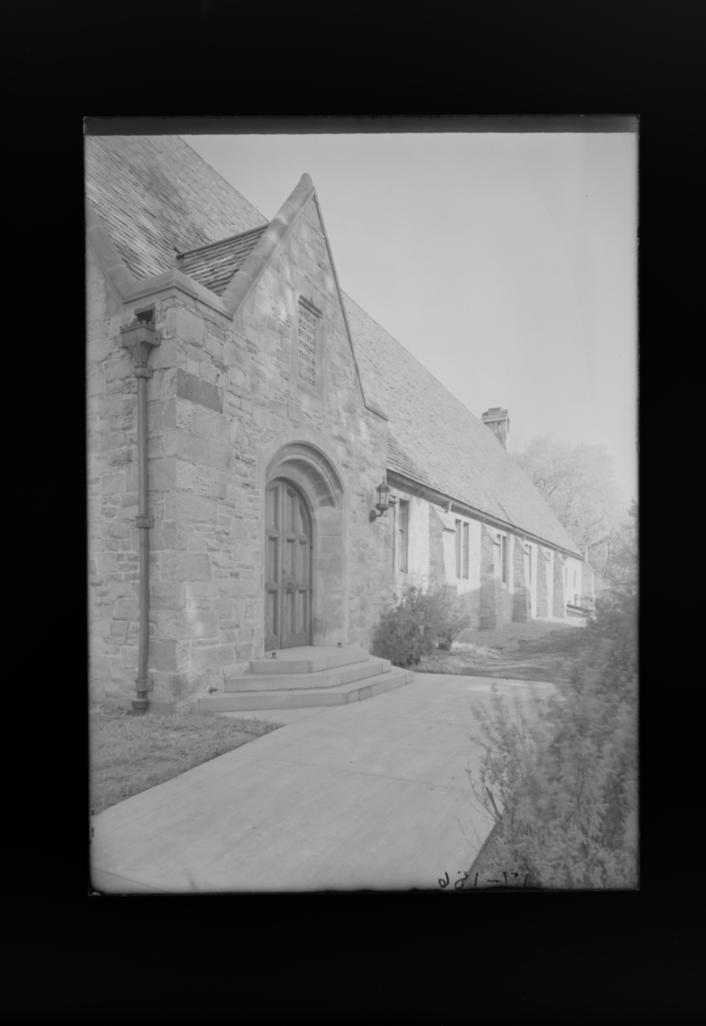

*The Auto Rotate before (Left) and after (Right) results. Notice the black edge on the left image becomes the bottom on the right.*

**CALIBRATE COLOR and TONE RESPONSE**

* + - 1. Back in the Digital Photo Professional 4 window:
         1. In the top right under ‘Camera Control’

1. Press the ‘Live View’ button to bring up the live view
2. Position a transparent color target squarely in the image frame
3. Focus the Lens on the color target.
4. Press the large Circular Button to capture an image
5. The image will appear in the middle of the DPP window
   * + - 1. Under the ‘Histogram’ panel
6. When moving the mouse through the image preview the RGB data will be reported in the bottom left of the histogram panel
7. After photographing a color target object , read the white RGB and black RGB values and using EOS Utility adjust your camera exposure and recreate the image until those values are within 2-3 points of their respective expectations
   * + - 1. Under the ‘Tools’ pallet there is a ‘Perform Basic Adjustments’ tab:
8. Under ‘White balance adjustment’ select the eyedropper tool
9. select a middle grey from the color target object
10. ensure that all other adjustments are off and zeroed out

**CREATE FLATFIELD CORRECTION**

* + - 1. Once the white balance and exposure are correct create the flat field correction file :
         1. Remove the color target from the image frame
         2. Ensure that the black auto rotate indicators are not present in the image frame
         3. Switch the camera lens to manual control and rotate the focus ring to put the image out of focus to hide dust and scratches on the table surface
         4. Produce a capture of the light table

Ensure that the light table surface is empty and clear of any objects

Ensure that the exposure of the bare light table is 2 one-third stop increments brighter than the correct exposure found with the color target

* + - * 1. Go to the master folder where the raw image file was saved
        2. Rename the raw image of the light table to ‘flatfield’, all lower case. So the file should now be ‘flatfield.cr2’
        3. Double click the ‘flatfield.bat’ file to create the ‘flatfield.tif’ image.
        4. Move the ‘flatfield.tif’ image file to the ‘Source’ folder
        5. Place the color target into the image frame and use it to refocus the camera lens

**RESET AND COMPLETE DIGITIZATION**

* + - 1. Exit out of ‘Remote Shooting’ in Digital Photo Professional’ (DPP)
      2. Re-Enter ‘Remote Shooting’ and
         1. Select the ‘Source’ folder created by the ‘Setup.bat’ file as the destination
         2. Leave the file naming as is.
      3. Within the master folder, double click the ‘hotfolder.bat’ file to start the conversion monitoring script.
      4. The ‘hotfolder.bat’ command prompt will open and ask for:
         1. The raw file type of your camera (ex cr2, nef, orf.. )
         2. The output DPI for the final tiff image
         3. The prefix if any for the sequential naming structure ( ex SDN-, ICHI-, HB_, DN-…_)
         4. The starting number for the sequential naming ( ex 1, 85000, 27, etc)
         5. Do you want a color target reference (‘yes’ or ‘no’). This will either add or not add a color reference to the final image. This reference is converted to the output dpi of the final ‘.tiff’ image making it always One inch. It serves as a reference of scale and tonal range as compared to the object being digitized.

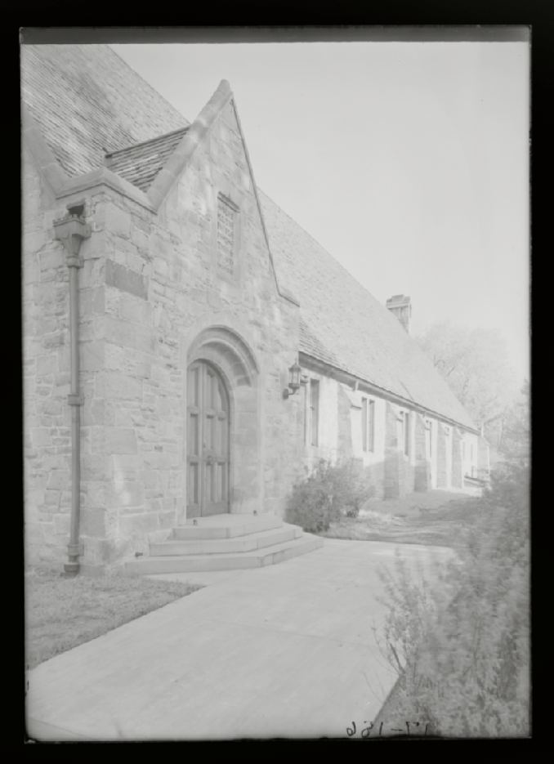 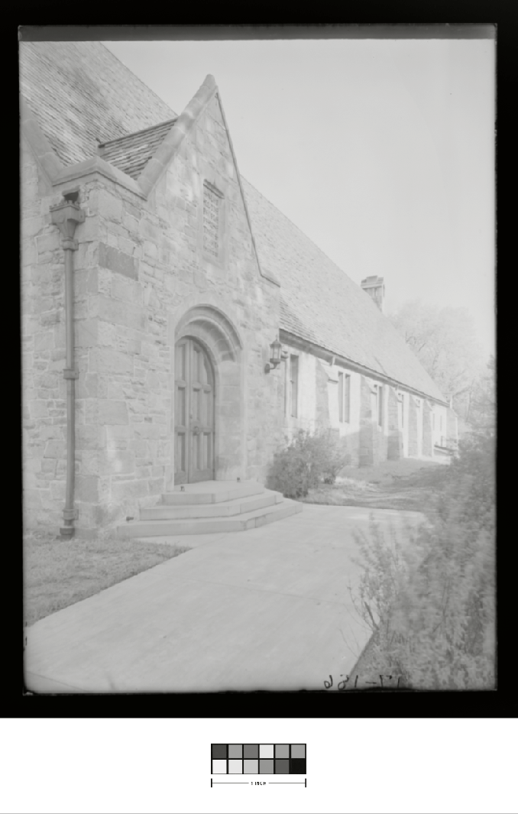

*(Left)Final image without target reference (Right) final image with target reference.*

* + - 1. Now produce photography for each negative using the correct exposure and framing.
      2. The ‘hotfolder’ batch file will convert each new raw image file in ‘source’ into a final tiff image and save them to the ‘output’ folder as they are produced while also moving the edited raw images into the ‘raw’ folder once converted.
      3. To change the naming structure during production, you simply close the command prompt for ‘hotfolder.bat’ and restart the batch file.

**SHUTDOWN AND BACKUP IMAGE FILES**

* + - 1. When photography is complete:
         1. Exit out of DPP and power off the tethered camera
         2. Connect the laptop to the internal network via WIFI or Ethernet cable
         3. Copy the new digital images in the ‘output’ and ‘raw’ folder to a working folder on the server.
      2. You may now delete any and all files in the source ‘master’ folder on the laptop.